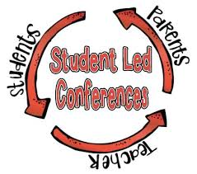
Student-Led Conferences
March 2018

Your child has been working very hard this term and would like to share some of his/her work with you. This is your time to allow your child to lead you through his/her learning.

Hints to ensure a successful and productive Student-Led Conference:

The student’s role is to:  -Lead, share, tour, show, and celebrate learning  -Feel proud of accomplishments | The parent’s role is to:  -Help, question, compliment, follow, listen, learn, and celebrate student’s learning  -Feel proud of child’s accomplishments

Student-Led Conference Activities
- Math
  - Activity: Addition and Subtraction Station
  - Location: Classroom

- Writing
  - Activity: Review Writing Folder and Writing Portfolio
  - Location: Classroom

- Reading
  - Activity: Discuss reading level and strategies
  - Location: Classroom
- Meet with teacher
  - Activity: Discuss work habits, behavior, strengths, and areas of growth
  - Location: Classroom
- Check that your child’s shoes still fit
- Science
  - Grade 1 Activity: Show cars
  - Grade 2 Activity: Show boats
  - Location: Hallway
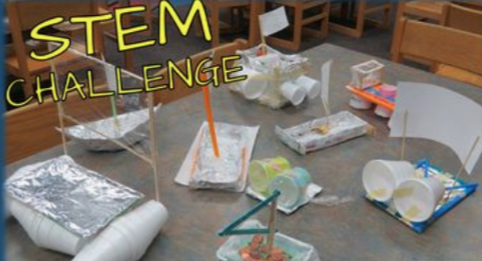

- Social Studies
  - Grade 1 Activity: Show model of Woodlands Community
  - Grade 2 Activity: Show model of Meteghan Community
  - Location: Learning Commons

- Art
  - Mixed Media Seascapes located on hallway bulletin board
  - Sunflowers located on top of Learning Commons bookshelves

- Music
  - Activity: Demonstrate music learning
  - Location: Music Room

- IRIS
  - Activity: Share “Understanding Myself as a Learner” and “Goals” in IRIS
  - Location: Learning Commons
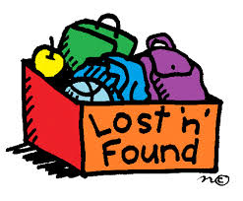
- Check the Lost and Found and pick up any belongings you may be missing

I hope you enjoyed the conference with your child and have a wonderful Spring Break! See you Tuesday, April 3, 2018!

